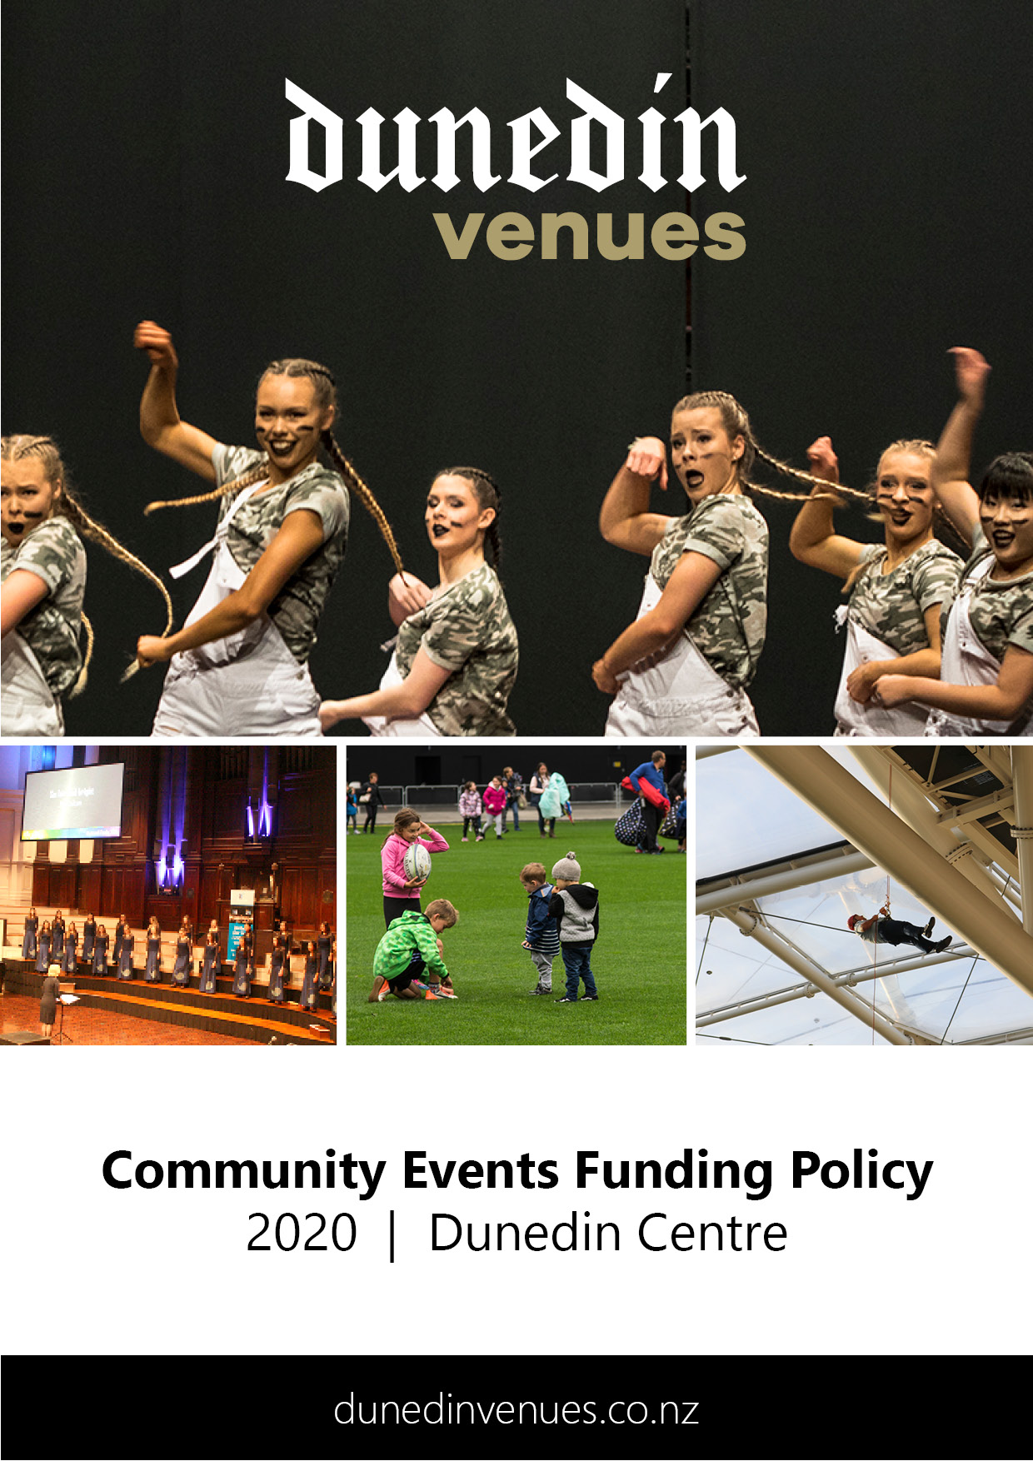

Community Access Grant Application
2020 | Dunedin Centre

Events that do not qualify for funding are listed below. Please check your application against these criteria prior to applying.
PRE-APPLICATION
Before beginning your Community Access Grant application:
- Check that your event will be eligible to be considered for the Community Access Grant. The following types of events do not qualify for this funding:
- Events or projects run by and for the benefit of commercial or profit-oriented organisations.
- Where a cash payment must be paid to attend (koha or donations are exempt).
- Events or projects that have already taken place (there is no retrospective funding).
- Events or projects that have a political or religious purpose.
- Events or projects whereby an organisation, group of people or a person financially benefits from the Community Access Grant (registered charities are exempt).
- Read the Community Events Funding Policy for the Dunedin Centre.

Applications open: 3 February 2020
Applications close: 2 March 2020, 5pm
For events held: 1 July 2020 – 31 December 2020

Once all parts of your application are completed, submit your application in one of the following ways:
- Email to:
info@dunedinvenues.co.nz
- Hand-deliver to:
Dunedin Venues Management Limited
Reception, Door J, Forsyth Barr Stadium
- Post to:
Dunedin Venues Management Limited
130 Anzac Avenue
PO Box 5506
Dunedin 9054

You will be sent an email to confirm your application has been received.

APPLICATION INFORMATION

Funding Applicant
Group/Name of Organisation | Click or tap here to enter text.
Contact Name | Click or tap here to enter text.
Address | Click or tap here to enter text.
Contact Number(s) | Click or tap here to enter text.
Email | Click or tap here to enter text.
Website | Click or tap here to enter text.

Event Organiser (if different from Funding Applicant)
Group/Name of Organisation | Click or tap here to enter text.
Contact Name | Click or tap here to enter text.
Address | Click or tap here to enter text.
Contact Number(s) | Click or tap here to enter text.
Email | Click or tap here to enter text.
Website | Click or tap here to enter text.

Status of Applicant/Organisation– certification may be required (tick one)
☐ Charitable Trust
☐ Incorporated Society
☐ Limited Liability Company
☐ Not for Profit
☐ Other
Click or tap here to enter text.

Main Purpose of Organisation (tick one)
☐ Cultural/Arts
☐ Social/Community/Health
☐ Sporting
☐ Educational
☐ Other (please specify)
Click or tap here to enter text.

Have you requested or been granted other funding for this event?
☐ No
☐ Yes (please specify who you applied to, whether you were allocated funding, and if so, to what value)
Click or tap here to enter text.

How did you hear about the Community Access Grant?
☐ Social Media
☐ Radio
☐ Newspaper
☐ An email from Dunedin Venues
☐ Other (please specify)
Click or tap here to enter text.

EVENT INFORMATION

Event Name

Click or tap here to enter text.

Event Details
Event Date (first preference): Click or tap here to enter text.
Event Date (second preference): Click or tap here to enter text.
Regular event with multiple dates: Click or tap here to enter text.
Refer to the Event Calendar in APPENDIX ONE for dates available at the Dunedin Centre.
Event Start Time: Click or tap here to enter text.
Event Finish Time: Click or tap here to enter text.

Pack-in / Pack-out

Pack-in Date: Click or tap here to enter text.
Pack-in Start Time: Click or tap here to enter text.
Pack-out Date: Click or tap here to enter text.
Pack-out Finish Time: Click or tap here to enter text.

For ticketed events (i.e. if you are charging entry fee), tick your preferred option for pack-in/pack-out dates:
☐ Guaranteed pack-in/pack-out date (50% rental to be paid by the hirer)
☐ Non-guaranteed pack-in/pack-out date (no venue rental to be paid; pack-in/pack-out booking may be terminated within four weeks of the event should a commercial booking be received)
Notes
Click or tap here to enter text.

Type of Funding Requested
The type and level of funding requested is:
☐ 100% Venue Rental and Event On-Charges (Free Event for all or a donation requested)
☐ 50% Venue Rental and Event On-Charges (Ticketed Event)
Refer to the Rate Card in APPENDIX TWO before completing.

Participants / Spectators
- Forecast number of spectators: Click or tap here to enter text.
- Forecast number of active participants: Click or tap here to enter text.

Financial
Do you plan to charge a fee to participate or attend the event?
☐ No
☐ Koha or donation will be requested
☐ Yes, the event will be ticketed (specify price brackets)
Click or tap here to enter text.

Spaces required
Dunedin Centre space/s required for event:
☐ Dunedin Town Hall
☐ Glenroy Auditorium
☐ Fullwood Room
☐ Conference Room
Notes
Click or tap here to enter text.

Event Summary/Objectives
Please describe your event in a few brief sentences, outlining how it benefits the social, educational, cultural, environmental and/or physical wellbeing of the Dunedin community.

Click or tap here to enter text.

Please advise what plans are currently in place for the event
(tick all that apply and attach copies to your application)
☐ Event Delivery Plan (including options for backup venues)
☐ Business Plan
☐ Marketing Plan
☐ Floorplan Layout
☐ Health and Safety Plan
☐ Risk Mitigation Plan
☐ Other (please specify)
Click or tap here to enter text.

EVENT TYPE

Please indicate which of the following event types best describes your event (we recommend that you read through all event types before completing this section).

Major Commercial Events (Type 1)
☐ An event where a hirer will pay in excess of $10,000 for the hire of the space.
☐ An event with a projected attendance of 1,500 paying people.
☐ An event which gains National and/or International media exposure.
☐ The event requires no community funding.
Examples: Commercial Concerts and Events, Exhibitions and Conferences

Commercial Events (Type 2)
☐ An event with a projected attendance of approximately 1,000 paying people.
☐ An event which gains national media exposure.
☐ An event which may require subsidized community funding only.
☐ An event which requires a long lead in time due to the booking of production and entertainers
Examples: Concerts, Exhibitions, and Conferences

Large Community Event (Type 3)
☐ An event where the anticipated attendance is less than 1,000 paying people.
☐ An event which includes local and national entertainers.
☐ An event which requires community funding.
☐ Significant local media exposure.
Examples: Community Concerts and Fundraising Events

Medium Community Event (Type 4)
☐ An event where the anticipated attendance is 300 – 1,000.
☐ An event which requires full community funding.
☐ Some local media exposure.
Examples: School Productions

Small Community Event (Type 5)
☐ Events where the anticipated attendance is 25 - 299.
☐ An event which requires full community funding.
☐ No media exposure guaranteed.
Examples: Community funding/training seminar

Event Hierarchy
To assist all users, your event will be classed as a Type 2, 3, 4, or 5 at the time of booking. This determines the hierarchy of your event in terms of booking priority. For full definitions and criteria of all event types, please refer below.
Type 2 events cannot be rescheduled or cancelled.
Types 3, 4 and 5 may be cancelled or rescheduled with no less than twelve weeks’ notice should a Type 1 booking be accepted by Dunedin Venues Management Limited.
Type 4 and 5 may be cancelled or rescheduled with no less than sixteen weeks’ notice should a Type 2 booking be accepted by Dunedin Venues Management Limited.
Type 4 events take precedence over Type 5 events, should there be two events applying for a single date. Incidental community events should not take precedence over confirmed Type 2, 3, 4 or 5 events.
Please note that this fund does not support Commercial Events (Type 1 and 2).

DECLARATION

Please print, sign, and return this page with your application.

By signing below, you agree that all information provided in this application is true and accurate and in accordance with the Dunedin Venues Management Limited Community Events Funding Policy.

I/We Click or tap here to enter text.
Full Name

Click or tap here to enter text.
Address

have formally applied for funding under the Dunedin Centre Community Event Fund and confirm and warrant that to my/our knowledge the details set out in the application are true and correct in all respects.

Click or tap here to enter text. Click or tap here to enter text.
Signature Date

CONSIDERATION OF APPLICATIONS
- No late applications will be accepted.
- The application process, from deadline until notification, takes a maximum of eight weeks.
- Once confirmation is received, applicants should enter their event on the Dunedin City Events Calendar at www.dunedin.govt.nz/events/tell-us-about-an-event/tell-us-about-an-event.
- Applicants should endeavour to submit full and complete applications. Should an attachment be left out, the application will be returned to the applicant who will be required to return the application with the required attachments within one week.

APPENDIX ONE – Event Calendar
Dates available at the Dunedin Centre 1 July 2020 – 31 December 2020

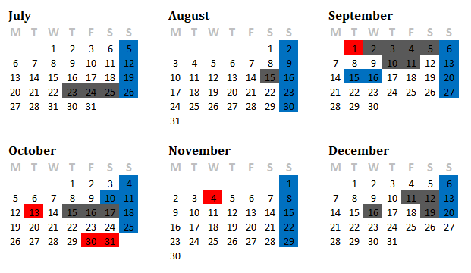
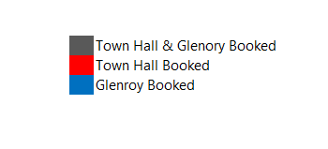

APPENDIX TWO – Rate Card

Non-ticketed/free events
You can apply for 100% venue rental and 100% additional event on-charge allowance.
Ticketed events
You can apply for 50% venue rental and 50% additional event on-charge allowance.

Venue Rental
Dunedin Town Hall | Non-ticketed /  free events | Ticketed events
Town Hall rental per day / event | $5000 | $2500
Event On-charge Allowance | $2000 | $1000

Glenroy Auditorium | Non-ticketed /  free events | Ticketed events
Glenroy Auditorium rental per day / event | $2500 | $1250
Event On-charge Allowance | $1500 | $750

Fullwood Room | Non-ticketed /  free events | Ticketed events
Fullwood Room rental per day / event | $1000 | $500
Event On-charge Allowance | $800 | $400

Conference Room | Non-ticketed /  free events | Ticketed events
Conference Room rental per day/event | $600 | $300
Event On-charge Allowance | $300 | $150

The Dunedin Centre is equipped with basic in-house audio and visual technology. The following items are included as part of the rental:

Dunedin Town Hall
  - Standard Stage wash lighting (no operator)
  - Basic audio rigged (no operator)
Glenroy Auditorium
  - Standard Stage wash lighting (no operator)
  - Basic audio rigged (no operator)
Conference Room
  - Basic internal audio system (no operator)
  - Visual projector
Fullwood Room
  - No AV or audio included

Event On-Charges

The Event On-charge Allowance can be used towards the following:
  - Security and Ushers (as determined by the Dunedin Venues Event Delivery Manager)
  - Cleaning
  - Stage extension install & removal ($300 + GST per row of stage extension built)
  - In house audio and visual equipment (no operator)
  - Organ ($300 + GST)
  - Piano ($200 + GST)
  - Traffic Management (incurred if Harrop St is closed)

Any costs exceeding the event on charge allowance will be at the direct expense of the hirer.

The Event On-charge Allowance does not cover the following:
  - Piano tuning
  - Stage ramp / loading ramp usage
  - Special lighting onto stage extension and / or full choir risers

These costs will be discussed with the hirer on a case-by-case basis.

