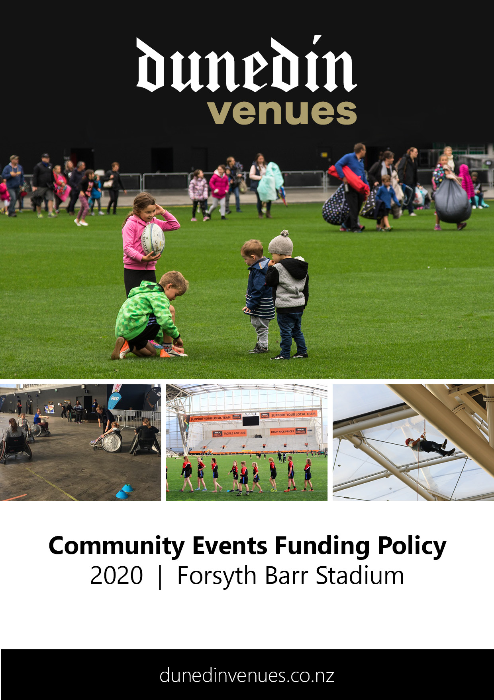

Community Access Grant Application
2020 | Forsyth Barr Stadium

PRE-APPLICATION
Before beginning your application for funding through the Community Access Grant:
- Check that your event will be eligible to be considered for the Community Access Grant. The following types of events do not qualify for this funding:
- Events or projects run by and for the benefit of commercial or profit-oriented organisations.
- Where a cash payment must be paid to attend (koha or donations are exempt).
- Events or projects that have already taken place (there is no retrospective funding).
- Events or projects that have a political or religious purpose.
- Events or projects whereby an organisation, group of people or a person financially benefits from the Community Access Grant (registered charities are exempt).
- Read the Community Events Funding Policy for the Dunedin Centre.

Applications open: 3 February 2020
Applications close: 2 March 2020, 5pm
For events held: 1 July 2020 – 31 December 2020

Once all parts of your application are completed, submit your application in one of the following ways:
- Email to:
info@dunedinvenues.co.nz

- Hand-deliver to:
Dunedin Venues Management Limited
Reception, Door J, Forsyth Barr Stadium

- Post to:
Dunedin Venues Management Limited
130 Anzac Avenue
PO Box 5506
Dunedin 9054

You will be sent an email to confirm your application has been received.

- APPLICATION INFORMATION

Funding Applicant
Group/Name of Organisation | Click or tap here to enter text.
Contact Name | Click or tap here to enter text.
Address | Click or tap here to enter text.
Contact Number(s) | Click or tap here to enter text.
Email | Click or tap here to enter text.
Website | Click or tap here to enter text.

Event Organiser (if different from Funding Applicant)
Group/Name of Organisation | Click or tap here to enter text.
Contact Name | Click or tap here to enter text.
Address | Click or tap here to enter text.
Contact Number(s) | Click or tap here to enter text.
Email | Click or tap here to enter text.
Website | Click or tap here to enter text.

Status of Applicant/Organisation– certification may be required (tick one)
☐ Charitable Trust
☐ Incorporated Society
☐ Limited Liability Company
☐ Not for Profit
☐ Other
Click or tap here to enter text.

Main Purpose of Organisation (tick one)
☐ Cultural/Arts
☐ Social/Community/Health
☐ Sporting
☐ Educational
☐ Other (please specify)
Click or tap here to enter text.

Have you requested or been granted other funding for this event?
☐ No
☐ Yes (please specify who you applied to, whether you were allocated funding, and if so, to what value)
Click or tap here to enter text.

How did you hear about the Community Access Grant?
☐ Social Media
☐ Radio
☐ Newspaper
☐ An email from Dunedin Venues
☐ Other (please specify)
Click or tap here to enter text.

EVENT INFORMATION

Event Name

Click or tap here to enter text.

Event Details
Event Date (first preference): Click or tap here to enter text.
Event Date (second preference): Click or tap here to enter text.
Regular event with multiple dates: Click or tap here to enter text.
Refer to the Event Calendar in APPENDIX ONE for dates available at Forsyth Barr Stadium.
Event Start Time: Click or tap here to enter text.
Event Finish Time: Click or tap here to enter text.

Pack-in / Pack-out

Pack-in Date: Click or tap here to enter text.
Pack-in Start Time: Click or tap here to enter text.
Pack-out Date: Click or tap here to enter text.
Pack-out Finish Time: Click or tap here to enter text.

Notes
Click or tap here to enter text.

Participants / Spectators
How many people do you expect at your event?
- Forecast number of spectators Click or tap here to enter text.
- Forecast number of active participants Click or tap here to enter text.
- Forecast number of providers (e.g. stallholders) Click or tap here to enter text.

Spaces Required
Forsyth Barr Stadium space/s required for event:
☐ Pitch (includes change and warm-up rooms)
☐ ODT Slab (concrete slab)
☐ Meeting Room (less than 50 people)
☐ Meeting Room (more than 50 people)
☐ Other (please specify) Click or tap here to enter text.
Notes:
Click or tap here to enter text.

Event Summary/Objectives
Please describe your event in a few brief sentences, outlining how it benefits the social, educational, cultural, environmental and/or physical wellbeing of the Dunedin community.

Click or tap here to enter text.

Please advise what plans are currently in place for the event
(tick all that apply and attach copies to your application)
☐ Event Delivery Plan (including options for backup venues)
☐ Business Plan
☐ Marketing Plan
☐ Floorplan Layout
☐ Health and Safety Plan
☐ Risk Mitigation Plan
☐ Other (please specify)
Click or tap here to enter text.

EVENT TYPE

Please indicate which of the following event types best describes your event (we recommend that you read through all event types before completing this section).

Major Commercial Events (Type 1)
☐ An event where a hirer will pay in excess of $10,000 for the hire of the space.
☐ An event with a projected attendance of 1,500 paying people.
☐ An event which gains National and/or International media exposure.
☐ The event requires no community funding.
Examples: Commercial Concerts and Events, Exhibitions and Conferences

Commercial Events (Type 2)
☐ An event with a projected attendance of approximately 1,000 paying people.
☐ An event which gains national media exposure.
☐ An event which may require subsidized community funding only.
☐ An event which requires a long lead in time due to the booking of production and entertainers
Examples: Concerts, Exhibitions, and Conferences

Large Community Event (Type 3)
☐ An event where the anticipated attendance is less than 1,000 paying people.
☐ An event which includes local and national entertainers.
☐ An event which requires community funding.
☐ Significant local media exposure.
Examples: Community concert, local sports competition finals

Medium Community Event (Type 4)
☐ An event where the anticipated attendance is 300 – 1,000.
☐ An event which requires full community funding.
☐ Some local media exposure.
Examples: Sports events, school events

Small Community Event (Type 5)
☐ Events where the anticipated attendance is 25 - 299.
☐ An event which requires full community funding.
☐ No media exposure guaranteed.
Examples: Sports trainings, entertainers rehearsals

Event Hierarchy
To assist all users, your event will be classed as a Type 3, 4, or 5 at the time of booking. This determines the hierarchy of your event in terms of booking priority. For full definitions and criteria of all event types, please refer below.
Type 2 events cannot be rescheduled or cancelled.
Types 3, 4 and 5 may be cancelled or rescheduled with no less than four weeks’ notice should a Type 1 booking be accepted by Dunedin Venues Management Limited.
Type 4 and 5 may be cancelled or rescheduled with no less than sixteen weeks’ notice should a Type 2 booking be accepted by Dunedin Venues Management Limited.
Type 4 events take precedence over Type 5 events, should there be two events applying for a single date. Incidental community events should not take precedence over confirmed Type 2, 3, 4 or 5 events.
Please note that this fund does not support Commercial Events (Type 1 and 2).

DECLARATION

Please print, sign, and return this page with your application.

By signing below, you agree that all information provided in this application is true and accurate and in accordance with the Dunedin Venues Management Limited Community Events Funding Policy.

I/We Click or tap here to enter text.
Full Name

Click or tap here to enter text.
Address

have formally applied for funding under the Forsyth Barr Stadium Community Events Fund and confirm and warrant that to my/our knowledge the details set out in the application are true and correct in all respects.

Click or tap here to enter text. Click or tap here to enter text.
Signature Date

CONSIDERATION OF APPLICATIONS
- No late applications will be accepted.
- The application process, from deadline until notification, takes a maximum of eight weeks.
- Once confirmation is received, applicants should enter their event on the Dunedin City Events Calendar at www.dunedin.govt.nz/events/tell-us-about-an-event/tell-us-about-an-event.
- Applicants should endeavour to submit full and complete applications. Should an attachment be left out, the application will be returned to the applicant who will be required to return the application with the required attachments within one week.

APPENDIX 1 June – 31 December 2020
