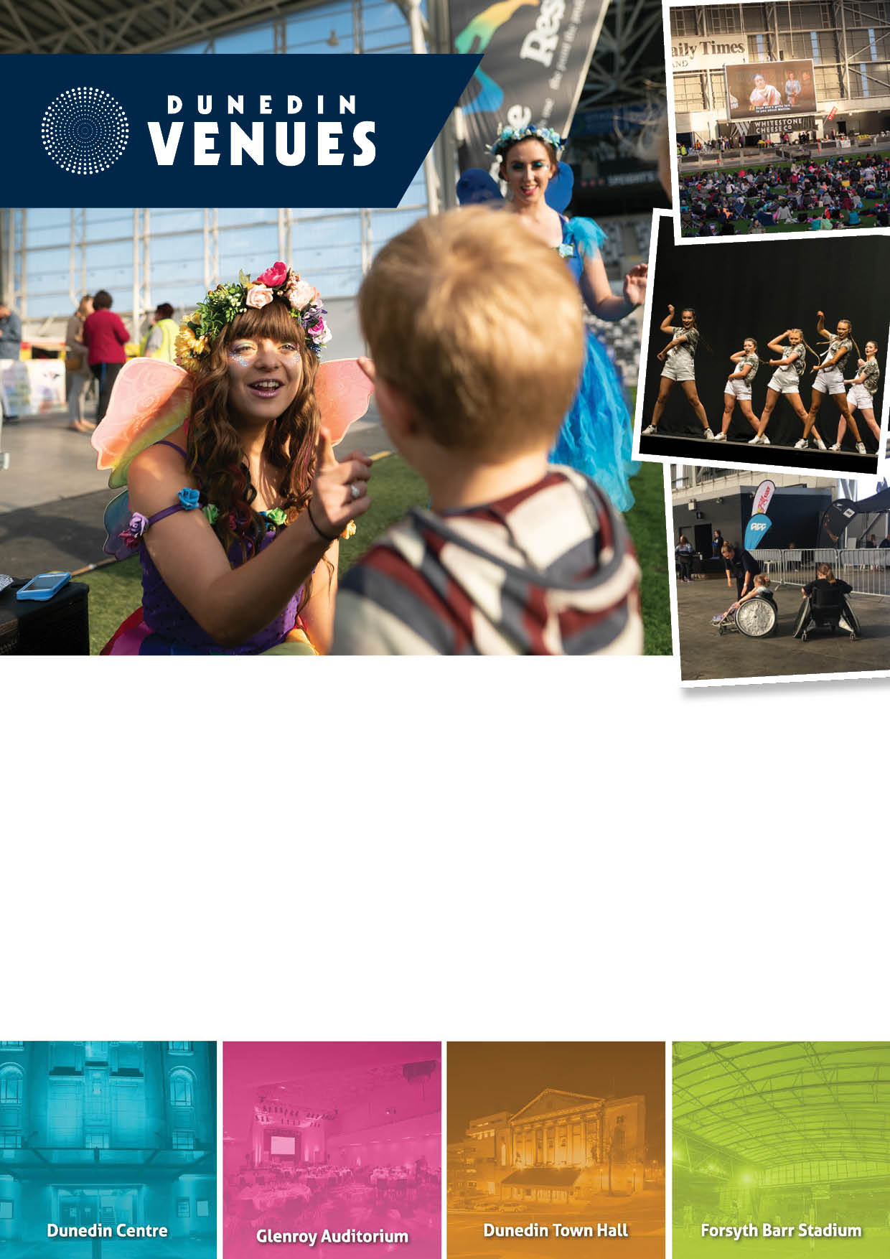

2019 | Forsyth Barr Stadium
Community Events Funding Application

Events that do not qualify for funding are listed below. Please check your application against these criteria prior to applying.

- Events/projects run by and for the benefit of commercial or profit-oriented organisations.
- Ticketed events/projects where a cash payment must be paid to attend (koha/donation are exempt).
- Events/projects that have already taken place (no retrospective funding).
- Events/projects that have a political or religious purpose.
- Events/projects whereby an organisation, group of people or a person financially benefits from the Community Access Grant (registered charitable organisations exempt).

Please ensure you have read the Community Events Funding Policy prior to completing this form.

Completed applications can be submitted through one of the following options:
- Email to info@dunedinvenues.co.nz

- Hand deliver to Dunedin Venues Management Limited reception at Forsyth Barr Stadium (Door J)

- Post to:
130 Anzac Avenue
PO Box 5506, Dunedin 9054

You will be sent an email to confirm your application has been received.

APPLICATION INFORMATION

Funding Applicant Details

Group / Name of Organisation | Click or tap here to enter text.
Contact Name | Click or tap here to enter text.
Contact Number(s) | Click or tap here to enter text.
Address | Click or tap here to enter text.
Email | Click or tap here to enter text.
Website | Click or tap here to enter text.

Event Organiser Details (if different from Funding Applicant)

Group / Name of Organisation | Click or tap here to enter text.
Contact Name | Click or tap here to enter text.
Contact Number(s) | Click or tap here to enter text.
Address | Click or tap here to enter text.
Email | Click or tap here to enter text.
Website | Click or tap here to enter text.

Status of Applicant / Organisation (tick – certification may be required)
☐ Charitable Trust
☐ Incorporated Society
☐ Limited Liability Company
☐ Not for Profit
☐ Other Click or tap here to enter text.

Main Purpose of Organisation (tick)
☐ Sporting
☐ Educational
☐ Cultural/Arts
☐ Social/Community/Health
☐ Other (please specify): Click or tap here to enter text.

Have you requested or been granted other funding for this event (tick)
☐ No
☐ Yes (please specify who you applied to, whether you were allocated funding, and if so, to what value):

EVENT INFORMATION

Name of Event: Click or tap here to enter text.

Date of Event Click or tap here to enter text.
First Preference Date: Click or tap here to enter text.
Second Preference Date: Click or tap here to enter text.
Regular event with multiple dates: Click or tap here to enter text.
Please ensure you refer to the Calendar in APPENDIX ONE for available dates before completing.

Event Start / Finish time
Event Start Time: Click or tap here to enter text.
Event Finish Time: Click or tap here to enter text.
If pack in/out is scheduled on the day of the event please answer below:
Pack-in Start Time: Click or tap here to enter text.
Pack-out Finish Time: Click or tap here to enter text.

Pack in / Pack out (tick)
If the event requires a pack-in / pack-out day before and/or after the event, please tick:
☐ Pack-in
☐ Pack-out
Pack-in Start Time: Click or tap here to enter text.
Pack-out Finish Time: Click or tap here to enter text.

Notes:Click or tap here to enter text.

Participants / Spectators:
How many people do you expect at your event? Click or tap here to enter text.
- Forecast number of spectators Click or tap here to enter text.
- Forecast number of active participants Click or tap here to enter text.
- Forecast number of providers (e.g. stallholders) Click or tap here to enter text.

Spaces Required: (tick)
Forsyth Barr Stadium space/s required for event:
☐ Pitch (includes change and warm-up rooms)
☐ ODT Slab (concrete slab)
☐ Meeting Room (less than 50 people)
☐ Meeting Room (more than 50 people)
☐ Other (please specify)

Notes: Click or tap here to enter text.

Event Summary / Objectives:
In a few brief sentences, please describe your event and how it benefits the social, educational, cultural, environmental and or physical wellbeing of the Dunedin community.
Click or tap here to enter text.

Please advise what plans are currently in place for the event (please note, all plans must be made available on request): (tick)

☐ Event Delivery Plan (including back up venue plans)
☐ Business Plan
☐ Marketing Plan
☐ Floorplan layout
☐ Health and Safety Plan
☐ Risk Mitigation Plan
☐ Other

EVENT TYPE

Community Event Hierarchy
To assist all users, your event will be classed as a Type 3, 4, or 5 at the time of booking. This determines the hierarchy of your event in terms of booking priority. For full definitions and criteria of all event types, please refer below.
Types 3, 4 and 5 may be cancelled or rescheduled should a Type 1 booking be required by Dunedin Venues Management Limited with no less than four weeks’ notice.
Type 4 and 5 may be cancelled or rescheduled should a Type 2 booking be required by Dunedin Venues Management Limited with no less than sixteen weeks’ notice.
Type 4 events take precedence over Type 5 should there be two events applying for a single date. Where there is a clash, Dunedin Venues Management Limited will work with event organisers to identify a suitable alternative date.
Please note that this fund does not support Commercial Events (Type 1 and 2).

Event Type

Please tick the appropriate boxes below to determine the Type of event proposed (please read all event types before completing):

Large Community Event (Type 3)
☐ An event where the anticipated attendance is greater than 2,000 (including spectators and active participants)
☐ An event where national competitors travel from other regions to participate
☐ Significant local media exposure

Examples: Community concert, local sports competition finals

Medium Community Event (Type 4)
☐ An event where the anticipated attendance is 300 – 1999 (including spectators and active participants)
☐ Some local media exposure

Examples: Sports events, school events

Small Community Event (Type 5)
☐ An event where the anticipated attendance is 25 – 299 (including spectators and active participants)
☐ Media exposure not guaranteed

Examples: Sports trainings, entertainers rehearsals

DECLARATION

Please print, sign, and return this page with your application.

By signing below you agree that all information provided in this application is true and accurate and in accordance with the Dunedin Venues Management Limited Community Events Funding Policy.

I/We Click or tap here to enter text.
Full Name

Click or tap here to enter text.
Address

have formally applied for funding under the Forsyth Barr Stadium Community Events Fund and confirm and warrant that to my/our knowledge the details set out in the application are true and correct in all respects.

Click or tap here to enter text. Click or tap here to enter text.
Signature Date

CONSIDERATION OF APPLICATIONS
- No late applications will be accepted.
- The application process, from the deadline until notification, takes a maximum of eight weeks.
- Once confirmation is received, applicants should enter their event on the Dunedin City Events Calendar at www.dunedin.govt.nz/events/tell-us-about-an-event/tell-us-about-an-event.
- Applicants should endeavour to submit full and complete applications. Should an attachment be left out, the incomplete application will be returned to the applicant who has one week to return the amended application.

APPENDIX 1st July – 31st December 2019

